model catalog 2016

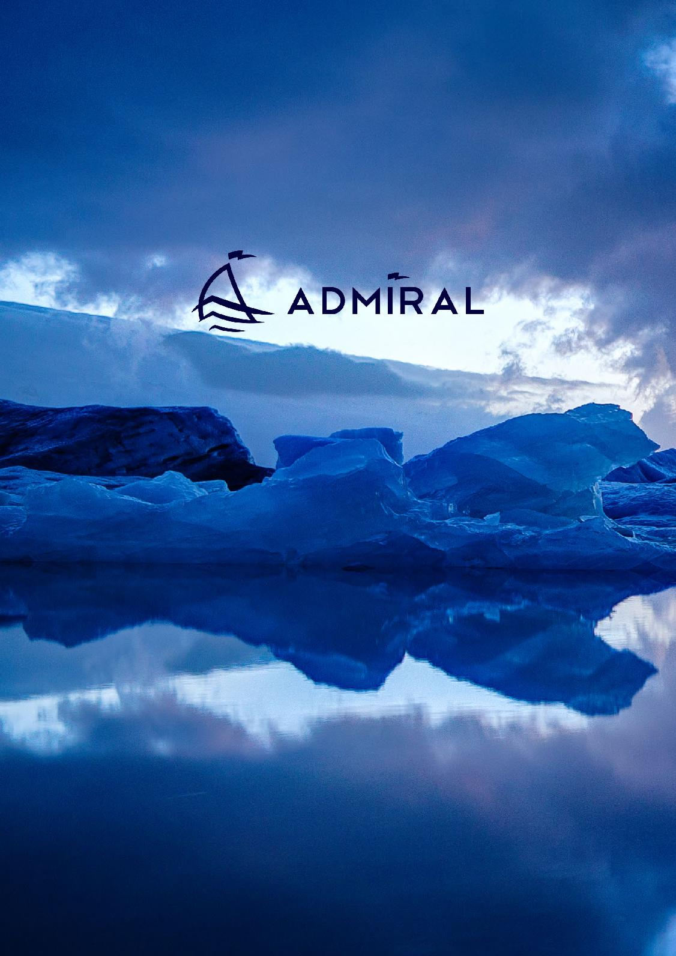

ADVANTAGE IN EVERY MOVEMENT AND convenience in every detail

boats and equipment saint-petersburg, russia 2009 - 2016

TRUFFIMPEX Ltd
truffimpex@hotmail.fr
Mr Tricoire Thierry
Tel : +359/893 745 632



ADMIRAL – one of the largest manufacturers of inflatable boats

in CIS countries with production site located in Saint Petersburg, Russia.

ADMIRAL is fast developing and export oriented Russian company. ADMIRAL produces inflatables for both the leisure and professional smarkets. ADMIRAL has a long established reputation for innovative design, superior construction, and outstanding customer satisfaction. We combine top grade high technology materials with years

of experience in boats production. Highly skilled engineers and designers ensure the usability and safety.

ADMIRAL has a wide range of products starting from small yacht tenders and raw boats to big seaworthy boats. We never shied away from the hard work of refining our existing models and designing new inflatables.

What is an inflatable boat?

An inflatable boat is a lightweight boat constructed with its sides and bow made of flexible tubes containing pressurized gas. For smaller boats, the floor and hull is often flexible, while for boats longer than 3 meters, the floor typically consists of three to five rigid plywood or aluminum sheets fixed between the tubes with rigid transom for outboard motor. The main advantage of every inflatable boat is its inflatable buoyancy tube.

This most important part of every inflatable gives some incredible features to them:

The boat becomes about 2 times wider, which sufficiently increases stability.

The combination of the inflatable buoyancy tube with V-shape bottoms makes its seaworthiness really fantastic.

The boat has a multi-chamber tube with an incredible buoyancy volume. It guarantees unbelievable safety, carry and passenger capacities.

The main body materials are light and flexible. It makes the boat light, portable, easy in storage and transportation.

WHY ADMIRAL?

The main value – is our customers.

Our customers drive our desire for constant innovations, improvement of goods quality and customer service.

We adopt the design according to customer desires and each market particularities.

We are using only top grade materials for the production.

Each model is CE certificated.

We are providing best and optimal logistic service: sea freight, air shipment or truck delivery.

All the goods are handmade. We have a strict control at all production stages.

We have a flexible price policy for each distributor, dealer and end customer.



boat Models

Yacht tenders

(built-in transom)

am-180 / AM-200 AM-230 / am-250 / AM-270
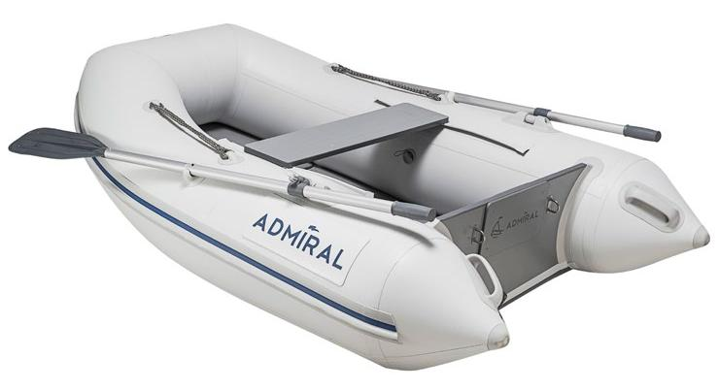

sport series

am-320s / am-340s / am-360s am-340sl
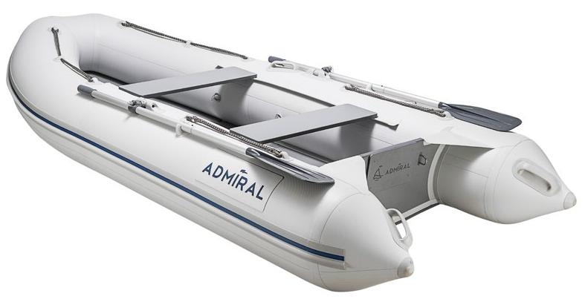

motor-rowing boats

(seaworthy)

am-380/am-410 am-430/am-450
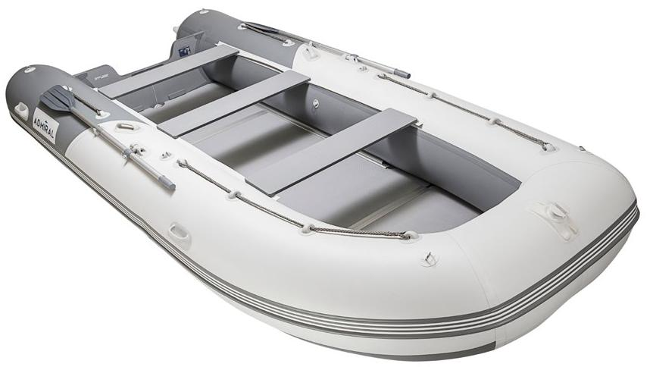
RAW BOATS

am-260 / am-260T am-280 / am-280t / am-280tp am-300t / am-300p / am-300tp
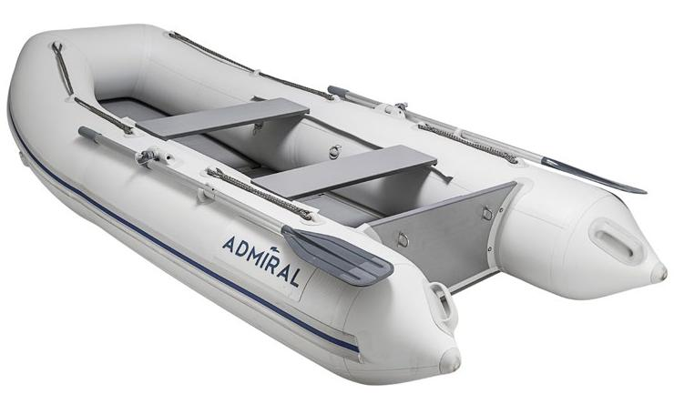

classic series

am-305c / am-320c am-305cl / am-320cl
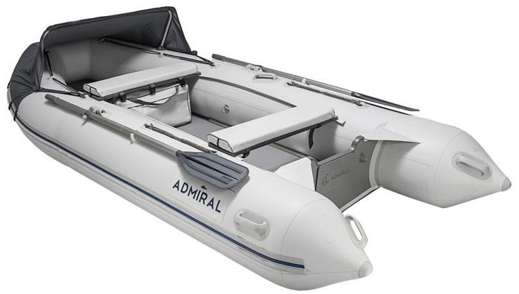

motor-rowing boats

(increased seaworthy)

am-480 am-500 am-520
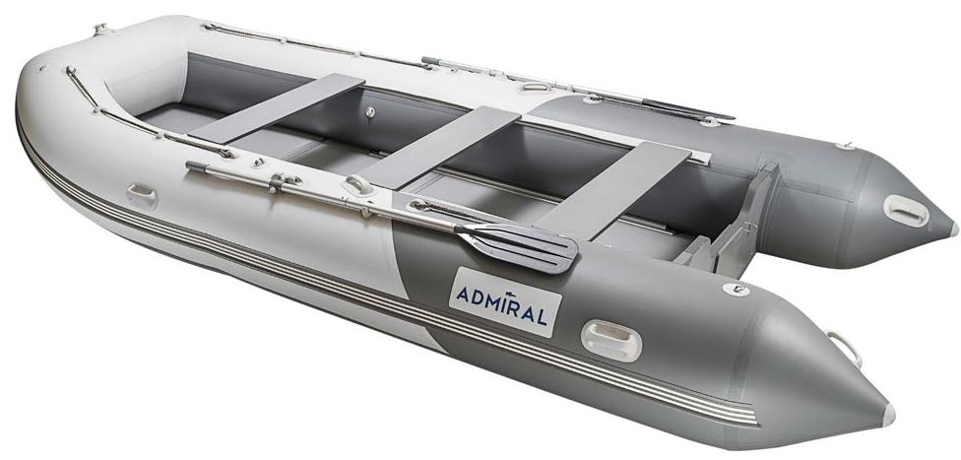

Model «С» – Classic.

Model «СL» – Classic lux (Large cockpit. In a set, tent for the front part, two pads). Model «S» – Sport (Narrower nose).

Yacht tenders

(built-in transom)

am-180 / AM-200

SPECIFICATIONS: |  | am-180*
Length | 1800 / 2000 mm
Width | 1380 / 1380 mm
Cockpit length | 1060 / 1280 mm
Cockpit width | 580 / 580 mm
Tube diametr | 400 / 400 mm
Number of sealed sections | 2+1 / 2+1
Max. bearing capacity | 265 / 290 kg
Max. passenger capacity (persons) | 1 / 1
Max. motor power, H.P. | 2,5 h.p./ 2,5 h.p.
Overall boat weight | 18 / 21 kg
Transom height | 390 / 390 mm
Tubes, m³ | 0,34 / 0,39 mm
DELIVERY SET:
Inflatable boat | 1 pc
Hard seat (bench) | 1 pc
Oar | 2 pcs
Pedal air donkey | 1 pc
Timber flooring (a set) | 1 pc
Stringers set (a set) | 1 pc
Boat bag | 1 pc | am-200*
Timber flooring bag | 1 pc
A case for the stringers set | 1 pc
Repair kit in a package | 1 pc
(glue in a tube, PVC fiber for pads,
valve adapter, Operation Manual)
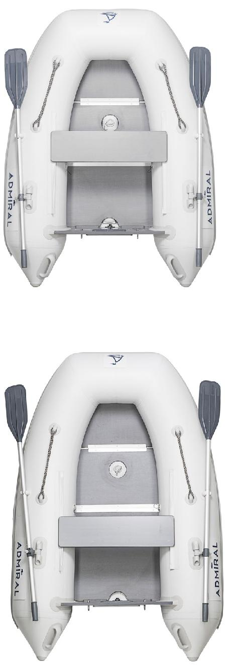

am-200*
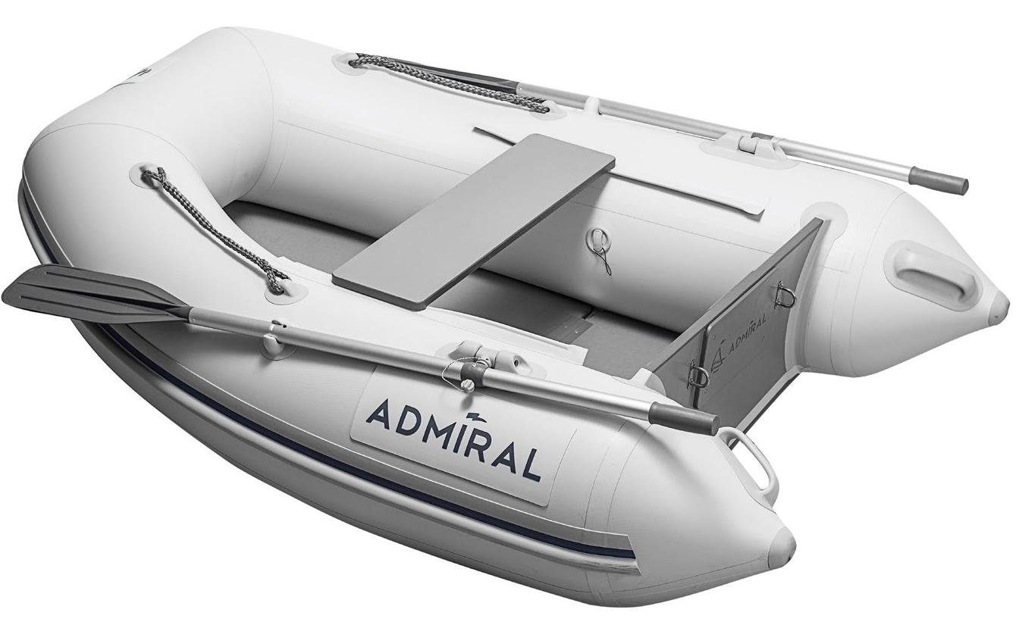
Yacht tenders

(built-in transom)

AM-230 / am-250 / AM-270

SPECIFICATIONS: |  | am-250*
Length | 2300 / 2500 / 2700 mm
Width | 1380 / 1380 / 1380 mm
Cockpit length | 1530 / 1720 / 1900 mm
Cockpit width |  | 580 / 580 / 580 mm
Tube diametr | 400 / 400 / 400 mm
Number of sealed sections |  | 3+1 / 3+1 / 3+1
Max. bearing capacity |  | 325 / 350 / 375 kg
Max. passenger capacity (persons) |  | 1 / 2 /2
Max. motor power, H.P. |  | 2,5 / 2,5 / 2,5 h.p.
Overall boat weight |  | 25 / 28 / 31 kg
Transom height |  | 420 / 420 / 420 mm
Tubes, m³ |  | 0,45 / 0,5 / 0,55
DELIVERY SET:
Inflatable boat |  | 1 pc
Hard seat (bench) |  | 1 pc
Oar |  | 2 pcs
Pedal air donkey |  | 1 pc
Timber flooring (a set) |  | 1 pc
Stringers set (a set) |  | 1 pc
Boat bag |  | 1 pc
Timber flooring bag |  | 1 pc
A case for the stringers set |  | 1 pc
Repair kit in a package |  | 1 pc
(glue in a tube, PVC fiber for pads,
valve adapter, Operation Manual)
 |  | am-270*
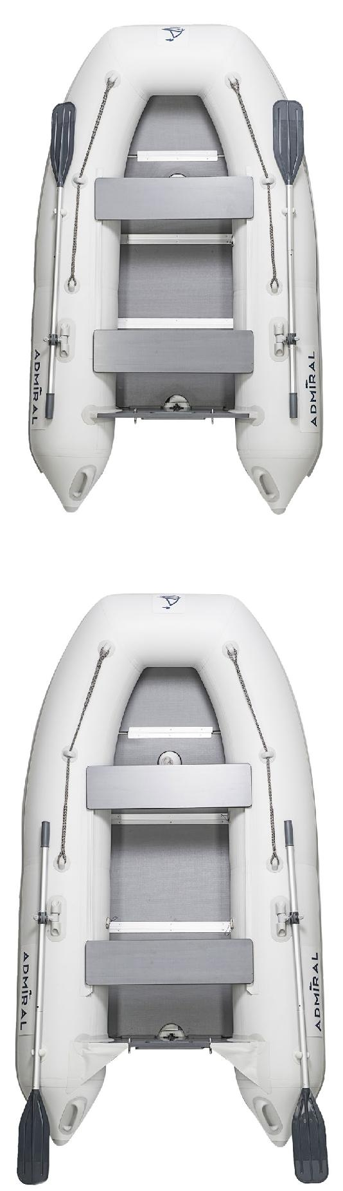

am-270*
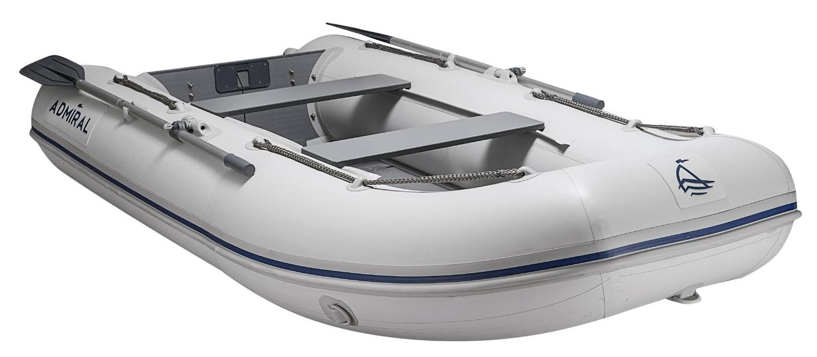
RAW BOATS

am-260 / am-260T am-280 / am-280t / am-280tp am-300t / am-300p / am-300tp
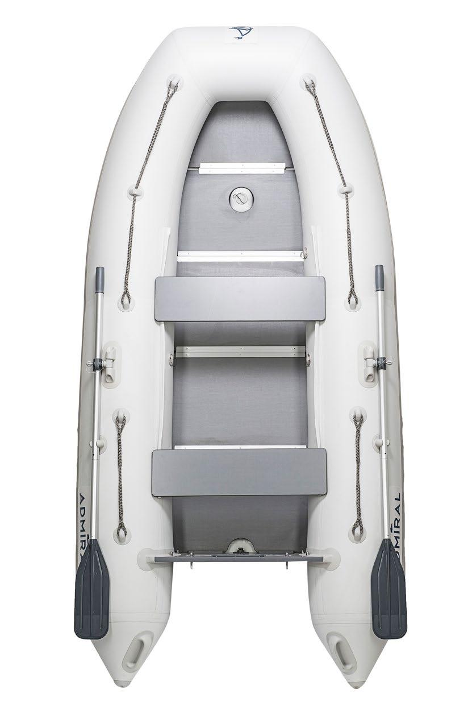

SPECIFICATIONS: | am-280*
Length | 2600 / 2800 / 300 mm
Width | 1380 / 1380 / 1480 mm
Cockpit length | 1800 / 2000 / 2200 mm
Cockpit width | 580 / 580 / 580 mm
Tube diametr | 400 / 400 / 400 mm
Number of sealed sections | 3+1 / 3+1 / 3+1
Max. bearing capacity | 200 / 210 / 200 kg
Max. passenger capacity (persons) | 1 / 2 / 2
Max. motor power, H.P. | 3 / 3,5 / 3,5 h.p.
Overall boat weight | 18 / 22 / 22,5 kg
Transom height | 390 / 390 / 390 mm
Tubes, m³ | 0,6 / 0,65 / 0,7
Overall dimensions | 900*300*650 mm
of the boat packing (mm)
Overall dimensions | 600*400*800 mm
of the timber flooring (mm)
DELIVERY SET:
Inflatable boat | 1 pc
Hard seat (bench) | 2 pcs
Oar | 2 pcs
Pedal air donkey | 1 pc
Timber flooring (a set) | 1 pc
Stringers set (a set) | 1 pc
Boat bag | 1 pc
Timber flooring bag | 1 pc
A case for the stringers set | 1 pc
Repair kit in a package | 1 pc
(glue in a tube, PVC fiber for pads,
valve adapter, Operation Manual)
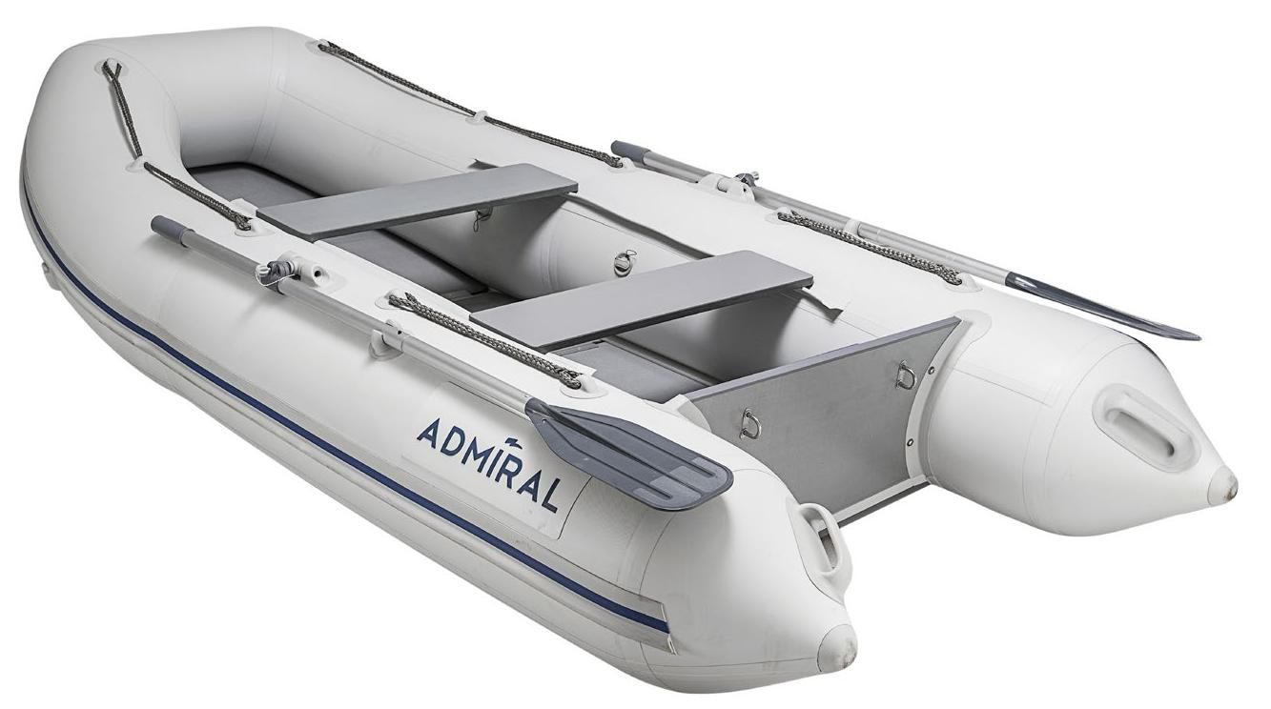

am-280*

sport series

am-320s / am-340s / am-360s am-340sl
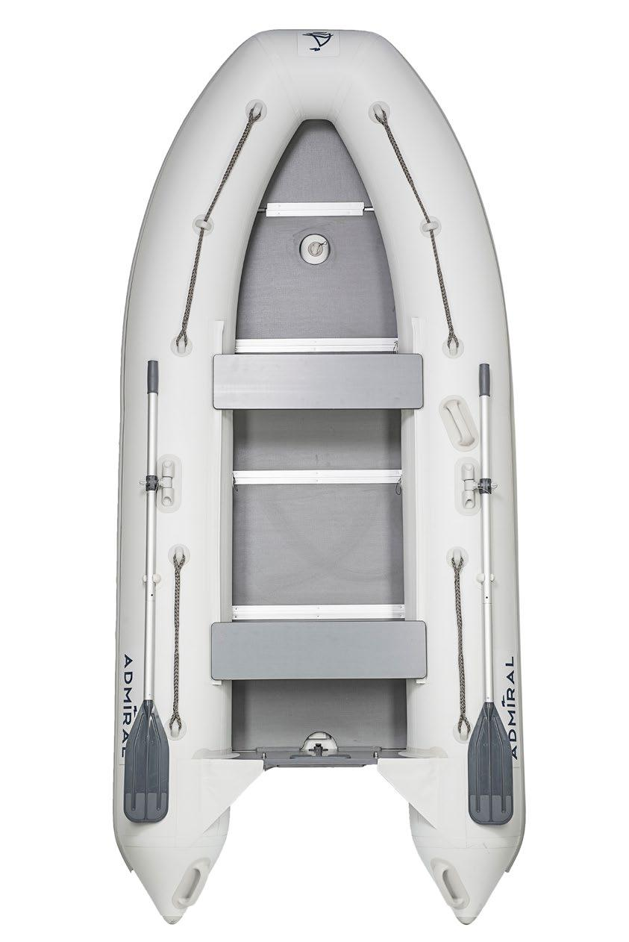

SPECIFICATIONS: | am-320S*
Length | 3200 / 3400 / 3600 mm
Width | 1430 / 1580 /1650 mm
Cockpit length | 2350 / 2440 / 2570 mm
Cockpit width | 630 / 680 /730 mm
Tube diametr | 400 / 450 / 450 mm
Number of sealed sections | 3+1 / 3+1/ 3+1
Max. bearing capacity | 450 / 600 / 700 kg
Max. passenger capacity (persons) | 4 / 5 / 5
Max. motor power, H.P. | 10 / 18 / 25 h.p.
Overall boat weight | 42,5 / 59 / 65 kg
DELIVERY SET:
Inflatable boat | 1 pc
Hard flooring of five sections (a set) | 1 pc
Longitudinal grider | 2 pcs
Hard seat (bench) | 2 pcs
Oar | 2 pcs
Packing bag for IMB | 1 pc
Packing bag for hard flooring | 1 pc
Pedal donkey | 1 pc
Adapter for air valve | 1 pc
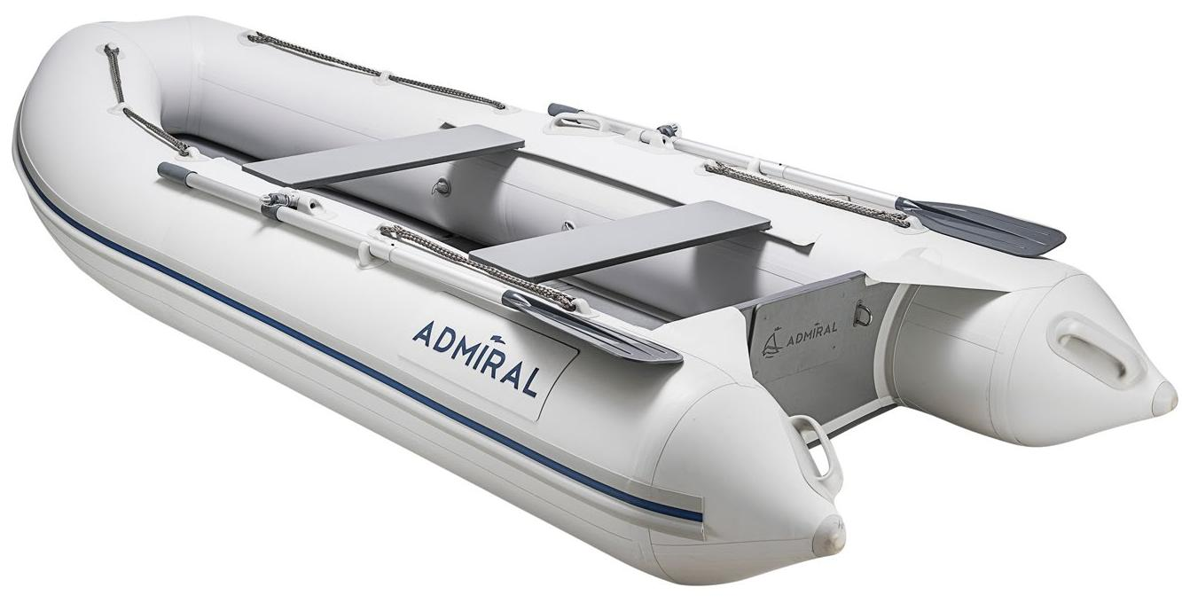

am-320C*

classic series

am-305c / am-320c am-305cl / am-320cl

SPECIFICATIONS: | am-320c*
Length | 3050 / 3200 mm
Width | 1450 / 1450 mm
Cockpit length | 2170 / 2290 mm
Cockpit width | 650 / 650 mm
Tube diametr | 400 / 400 mm
Number of sealed sections | 3+1 / 3+1
Max. bearing capacity | 425 / 450 kg
Max. passenger capacity (persons) | 4 / 4
Max. motor power, H.P. | 8 / 10 h.p.
Overall boat weight | 38 / 42 kg
DELIVERY SET:
Inflatable boat | 1 pc
Hard seat (bench) | 2 pcs
Oar | 2 pcs
Pedal air donkey | 1 pc
Timber flooring (a set) | 1 pc
Stringers set (a set) | 1 pc
Boat bag | 1 pc
Timber flooring bag | 1 pc
A case for the stringers set | 1 pc
Repair kit in a package | 1 pc
(glue in a tube, PVC fiber for pads,
valve adapter, Operation Manual)
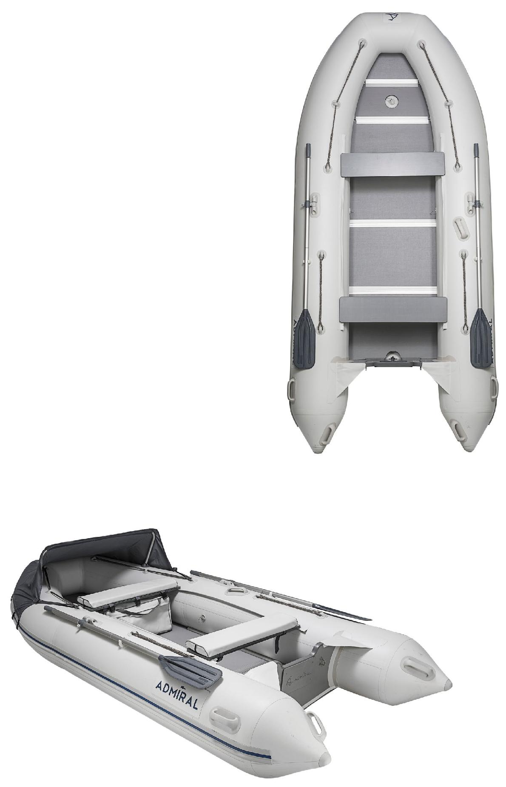

am-320cl*

motor-rowing boats

(seaworthy)

am-380/am-410 am-430/am-450
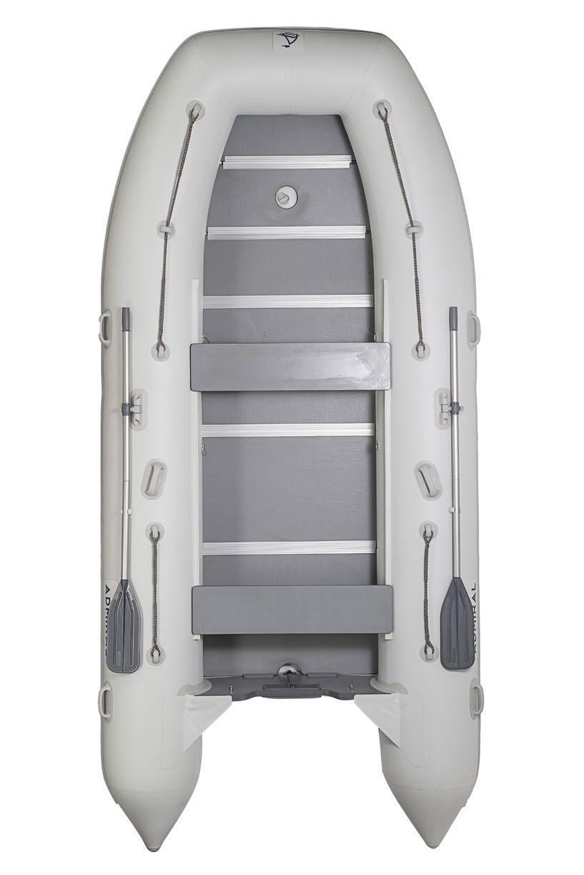

SPECIFICATIONS: | am-410*
Length | 3800 / 4100 / 4300 mm
Width | 1900 / 1900 / 2050 mm
Cockpit length | 2700 / 3000 / 3200 mm
Cockpit width | 900 / 900 / 950 mm
Tube diametr | 500 / 500 / 550 mm
Number of sealed sections | 4+1 / 4+1 / 4+1 / 4+1
Max. bearing capacity | 1000 / 1050 / 1250 kg
Max. passenger capacity (persons) | 7 / 7 / 8
Max. motor power, H.P. | 30 / 30 / 30 h.p.
Overall boat weight | 79,5 / 82,5 / 104 kg
DELIVERY SET:
Inflatable boat | 1 pc
Hard flooring of five sections (a set) | 1 pc
Longitudinal grider | 2 pcs
Hard seat (bench) | 2 pcs
Oar | 2 pcs
Packing bag for IMB | 1 pc
Packing bag for hard flooring | 1 pc
Pedal donkey | 1 pc
Adapter for air valve | 1 pc
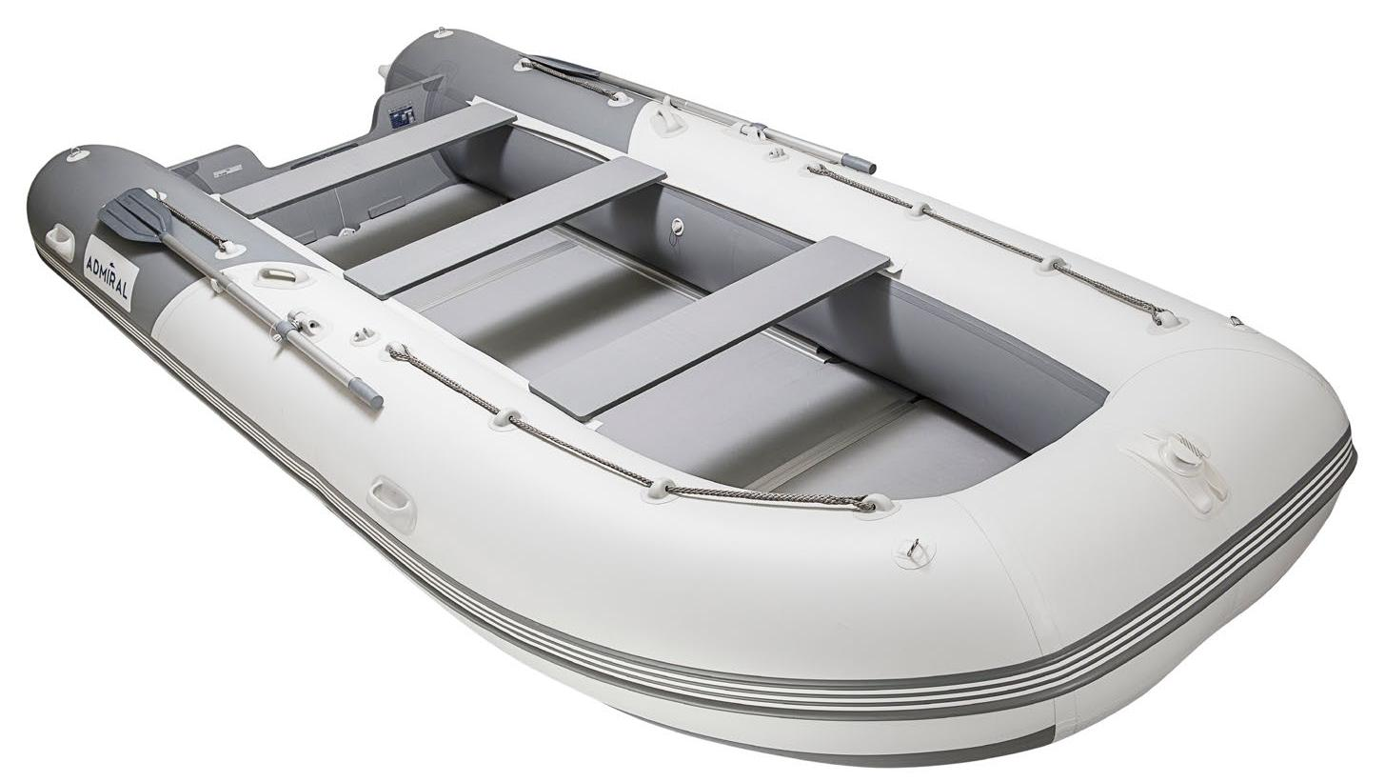

am-410*

motor-rowing boats

(increased seaworthy)

am-480 am-500 am-520
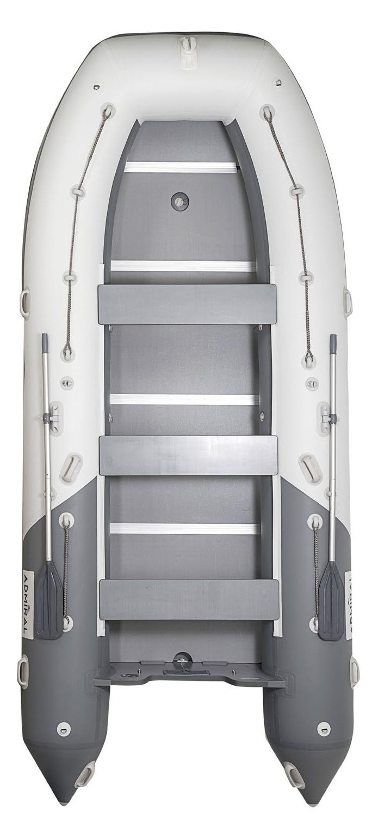

SPECIFICATIONS: | am-520*
Length | 4800 / 5000 / 5200 mm
Width | 2200 / 2200 / 2200 mm
Cockpit length | 3370 / 3540 / 3700 mm
Cockpit width | 1000 / 1000 / 1000 mm
Tube diametr | 600 / 600 / 600 mm
Number of sealed sections | 6+1 / 6+1 / 7+1
Max. bearing capacity | 1700 / 1800 / 1900 kg
Max. passenger capacity (persons) | 10 / 11 / 11
Max. motor power, H.P. | 50 / 50 / 50 h.p.
Overall boat weight | 110 / 113 / 118 kg
DELIVERY SET:
Inflatable boat | 1 pc
Hard flooring of five sections (a set) | 1 pc
Longitudinal grider | 2 pcs
Hard seat (bench) | 2 pcs
Oar | 2 pcs
Packing bag for IMB | 1 pc
Packing bag for hard flooring | 1 pc
Pedal donkey | 1 pc
Adapter for air valve | 1 pc
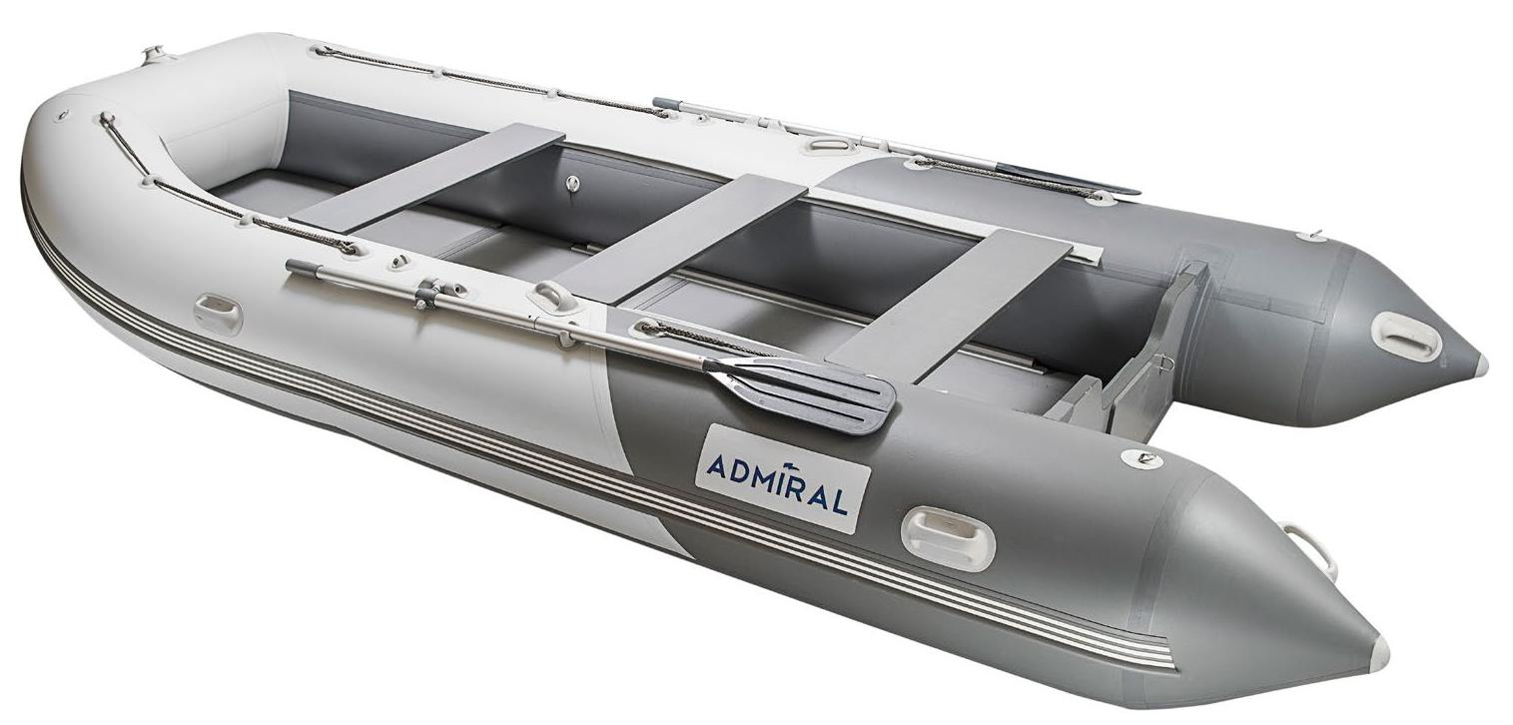

am-520*

